Code Smells Element 1 – Long Method List

This code smells occurs when exist a large and complex method.

**Code Snippet**

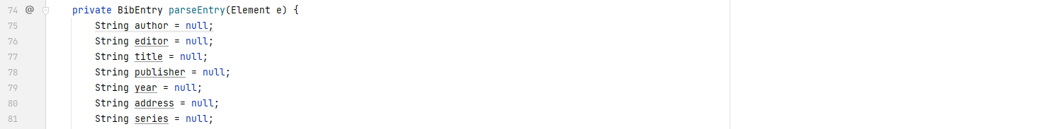

**…**

Method parseEntry() has 361 lines

**Code Location**

The path where this code smells is found (class path):

*“src\main\java\org\jabref\gui\openoffice\OOBibBase.java”*

**…**

**Justification**

As it shows above is a very long method with 301 lines of code and a lot of complexity, probably this method can be reduced and optimized so it can be easier to read and understand.

**Refactoring proposal**

There are a few solutions to this problem .Probably the method is more complex and long than it needs to be so it can be reduced and optimized. Other solution is to divide the method into sub methods so to be easier to understand.